To Search for an Associate Tutor
It is possible to search using a range of different search criteria:
- School
- Status
- Name
Click on the Find button. This will either return names below or take you straight into the Staff Pool details.

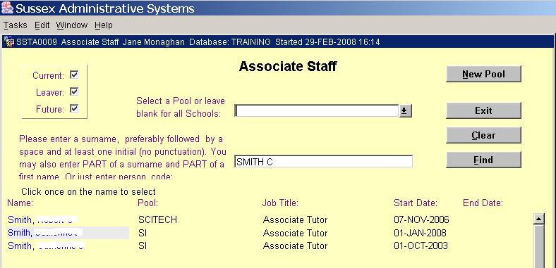
Enter search criteria. Enter a School or a surname
Clear to perform a new search
Click to Search

Search results are listed

To View an Associate Tutor's details
Click the name of the Tutor you wish to view. This will take you to another screen where you will be able to view their Adjustments, Allocations and Personal Details

You can:
- Add a tutor to a 2nd pool on the same grade
- Add a tutor to a 2nd pool on a different grade
- Add a tutor to the same pool on a different grade
Navigation
- Click any of the buttons along the bottom of the screen to view further information on a Tutor
- Click Back button to get back to staff pool details
- Click New Search button to get back to search screen
- Click Exit to return to the main menu

Adding Staff Member to a Pool
- In the search screen, select your school and click Find. This will take you into the ‘Staff Pool Details’ screen for your school.
- Click on the Add Staff button
- Enter the staff surname on the next screen and click on the Find button
- Click on the [Name] to enter person to your staff pool
- The job title will default to ‘Associate Tutor’ but can be changed
- Double-click in the Start Date field against your staff member to get the calendar. Enter their start date.
- Enter a Primary Department if desired
- Choose the grade the Tutor will be on.
- When you go into the Associate Staff screen for the Pool, the Proceed to HR flag will now be disabled; you need to click the School radio button. This will show all staff who need the ‘Proceed to HR’ flag setting. Set this as required and click the Save button to commit the changes. A contract will then be issued by HR

PLEASE NOTE: Only tick the ‘Proceed to HR’ flag if you want your associate tutor to be issued with an appointment contract by HR and be paid for their work.

If staff need to be added to a teaching group, but won’t be paid, then they should be added to the pool but the ‘Proceed to HR’ flag should not be ticked.

Click the School button to set ‘Proceed to HR’ flag
Click Exit to return to the main menu
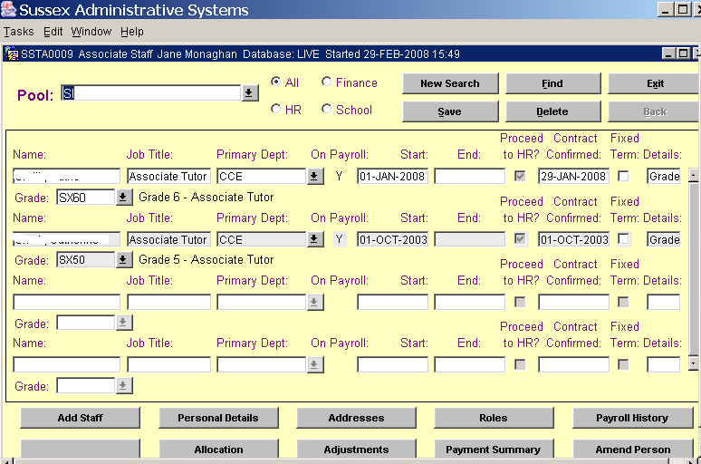
A Tutor may have two appointments on different grades within the same School pool
Click to add a new Associate Tutor
Click Back to get back to staff pool details

