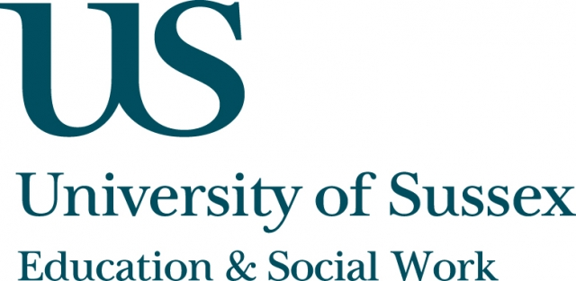

A CIRCY-hosted Workshop and Presentation

Monday 25th November, 4.15-7pm
Room 104, Fulton
Creating alternative narratives of social exclusion: Schooling, employment and identity
____________________________________

This is an open event for students, researchers and professionals interested in social exclusion.
Workshop
4.15 – 5.45pm
Researchers, practitioners and students will discuss issues relating to young people and social exclusion, exploring commonalities and differences and considering the following questions:
- What do we mean by ‘social exclusion’?
- Why is social exclusion an issue of particular importance for young people?
- Is there an alternative narrative of social exclusion to be developed? If so, what
does this mean for research and/or practice?
There will also be short presentations on (i) school exclusions and social
disadvantage in the UK, (ii) NEET transitions in Italy, and (iii) ‘road culture’ in London by Dr Louise Gazeley - Lecturer in Education, Fabio Gaspani - visiting PhD
researcher from Milan, and first year PhD researcher, Yusef Bakkali respectively.
Keynote Presentation
5.45 – 7pm
Professor Rob MacDonald, University of Teesside
Underemployment, precarité and downward mobility: the new condition of youth?
The keynote presentation will be filmed and available to view retrospectively: www.sussex.ac.uk/education/seminars
Refreshments provided
To reserve a place at this event, contact e.mcgeeney@sussex.ac.uk

