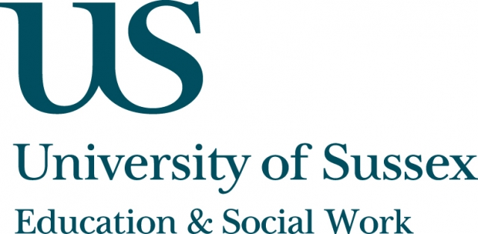

ESW Open Seminar Series
CIE

Monday 13th October, 4.30pm
Room 104, Fulton
Speaker
Dr Toni Verger, Department of Sociology Universitat Autónoma de Barcelona, Spain, presents:
The Global Diffusion of Education Privatization: Unpacking and Theorizing Policy Adoption
____________________________________

Due to the global dimension it is acquiring, education privatization
is a suitable phenomenon to look at from a policy diffusion perspective. Nevertheless, the dominant approaches to policy diffusion (namely, rationalism and normative emulation) are not sufficiently well-equipped to explain the dynamics of globalization
of education privatization in its complexity.
In this presentation, on the basis of theoretical currents like critical constructivism and cultural political economy, I present an alternative approach that focuses on the politics and semiotics of policy adoption. This approach contributes to explaining the global expansion of education privatization policies by unpacking the
most relevant moments that constitute policy adoption dynamics
(namely, variation, selection and retention) and looking at variables (i.e. the role of ideas and pluri-scalar interactions in politics) that
are often neglected in mainstream policy diffusion literature.
__________________________________
This seminar can be joined remotely by logging on to:
https://connectpro.sussex.ac.uk/cie_verger13oct14
This seminar will also be recorded and available to view
retrospectively at: www.sussex.ac.uk/education/seminars

