GUIDANCE FOR CAOs ON PROCESSING UNDERGRADUATE COURSE TRANSFER REQUESTS

Please note that this process applies only to UG (including Foundation) transfers where students are changing their degree subject(s). Please note that it may be used by students on a Foundation who wish to transfer straight onto a degree course for which they had already met the entry requirements (in Semester 1 only). Students who wish to add or remove a placement or study abroad year on their existing course are guided to contact their School Office rather than use the online transfer form. This is because we don’t require the same level of detail for these transfers and schools may not wish to implement them until a placement/study abroad host has been secured.

Students who wish to transfer back to year 1 or year 0 should apply directly to SSRO, who can process their transfer at any time. All other transfers back to an earlier stage of study will be processed by schools (but SSRO are happy to provide guidance to CAOs on fees and visas). Students who wish to temporarily withdraw and return to a different course in the next academic year may wish to discuss their transfer request outside of the standard transfer windows. Schools may process transfers for these students may any time.

When can students request transfers?

Students may request course transfers during two transfer windows:

- For Semester 1 – 1st August 2021 to 8th October 2021
- For Semester 2 – 10th December 2021 to 4th February 2022

During these windows, students may request a transfer via an online form on the webpages of the school which owns the new course. The form will need to be set up using either WCM or Google Forms by each school (if using Google Forms, please see instructions in Appendix A). You will open and close the transfer window by enabling/disabling the form.

Please note that students may only apply via the online form in the transfer window immediately prior to/during the semester in which it will be effective. Where a student temporarily withdraws and wishes to return to a different course in the next academic year, they can apply for their transfer at any time via SSRO as above. This is so that they can find out whether the transfer will be allowed before deciding whether or not to withdraw. Students who complete a stage but know they wish to transfer for the following academic year must wait for the Semester 1 transfer window to open on 1st August and apply via the online form in the usual way.

Step 1: Checking for transfer requests

Once the transfer window has opened, you will need to check for new responses regularly (once a day in the last three weeks before the deadline is recommended):

- You will need to set up a master spreadsheet to record and track transfers for each semester. All responses should be deleted from Google Forms/WCM once transferred to your master spreadsheet, to meet GDPR requirements.

Step 2: Initial checks to be done by CAO (or other PS colleagues within the school)

- Check that there is sufficient space on the modules for both Semester 1 and 2 on the new course

- Check that the structure of the old and new courses will allow the student to achieve 120 credits per stage. Where either the current or new course structure includes year-long modules, a Semester 2 transfer will not be possible.

- All transfers applied for via the online form (including transfers back to the beginning of an earlier stage and transfers from one Foundation course to another that will be effective within the current academic year) should be processed by the school. Transfers requested by students taking temporary withdrawal (i.e. transfers effective in the next academic year) will be process by SSRO.

- If the student has said that they pay overseas fees or is a sponsored overseas student, email studentprogress@sussex.ac.uk with the details of the transfer requested. The transfer can be considered straightaway but should not be confirmed until Student Progress have confirmed that the transfer can go ahead.

- If the course the student wishes to transfer onto has any additional entry requirements (e.g. a health check or criminal convictions disclosure), contact the student with information on what they need to do to meet these. The transfer can be considered straightaway but should not be confirmed until these additional requirements have been met.

If a transfer will not possible due to lack of space or the course structure, email the student to decline their transfer request.

Step 3: Sending the request for approval

Transfer requests will need to be sent to the Admissions Tutor of the department that owns the course. Where a student wishes to transfer to a joint or major-minor course, the Admissions Tutor of the owning department is responsible for contacting the Admissions Tutor of the other named department to check that they also approve the transfer. Email the following information to the Admissions Tutor of the owning department:

- UCAS Personal Identification for the student – this will allow them to see all entry qualifications including non-A-level ones. You can find this on the ‘Personal’ tab in Student Details on CMS:
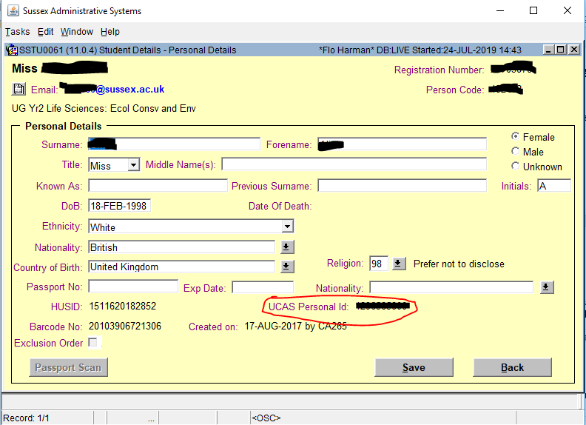
- Copy and paste from your tracking spreadsheet the student’s current and proposed course/stage, reason for requesting the transfer and email address (in case the Admissions Tutor needs to speak to the student about the transfer).

To give the Admissions Tutor access to the student’s academic record so far at Sussex, you will need to add them as a referee for the student via CMS. Please remember to remove them as referee once the transfer has been approved/declined. Log the date that you sent the request details to the Admissions Tutor on your tracking spreadsheet.

Step 4: Admissions Tutor considers request

In many cases the Admissions Tutor may be able to make a decision based on the information you have sent them, but they may wish to speak to the student before approving the transfer. If this is the case, they should arrange this with the student directly. Where the student has applied to transfer to a joint or major/minor course, the Admissions Tutor is responsible for checking that the other department concerned is happy to accept the student, where necessary.

Once they have reached a decision, the Admissions Tutor should email you to let you know whether they (and the joint/minor department) approve/reject the transfer.

Step 5: Implementing/Rejecting the Transfer

If the Admissions Tutor(s) has rejected the transfer: log the outcome of your transfer tracking spreadsheet and email the student to let them know, explaining briefly why the request was declined (e.g. they have not met the entry requirements/do not have sufficient academic experience in the relevant subject).

If the Admissions Tutor(s) has approved the transfer: log the outcome on the transfer tracking spreadsheet. If the student has met any additional entry requirements (e.g. a health check or DBS) and/or SSRO have confirmed the transfer can go ahead if the student is an overseas fee-payer/a sponsored overseas student, you can now update the student’s course title, Academic Advisor and core modules. Email the student to confirm the transfer (including their new expected end date), copying in the CAO of their old school and their old Academic Advisor, as well as their new Course Coordinator, Course Convenor and Academic Advisor. If relevant, include details of any optional or elective modules available to the student and ask them to confirm their choices as soon as possible. Log on tracking spreadsheet when all modules have been added and the transfer is complete.

Please see Appendix B for approval/rejection email templates.

Appendix A: How do I set up the transfer form for my school?

- If your school office team does not already have a Gmail account, you will need to create one.

- Go to Google Forms (you can find this by just searching ‘Google Forms’) and log in to your school’s account

- Select ‘Blank’ under ‘Create a new form’ and use the example form here as a template: https://forms.gle/47kgTMHwewNzpeAK9

- To add a new question, click on the + symbol. Click on the drop-down arrow to change the type of question you want to create:

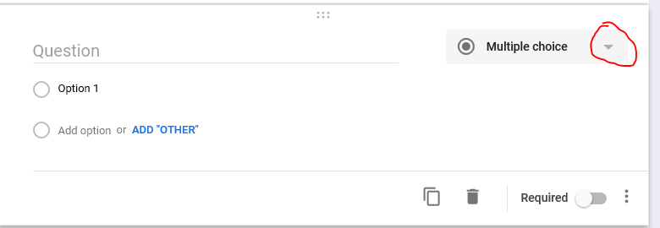

- For the question on the student’s proposed course, create a drop-down question and enter all the UG courses running in your school in the relevant academic year.

- Be sure to set each question to ‘required’ using the toggle beneath each question (visible once you click on that question in editing mode). This will prevent students submitting incomplete forms.

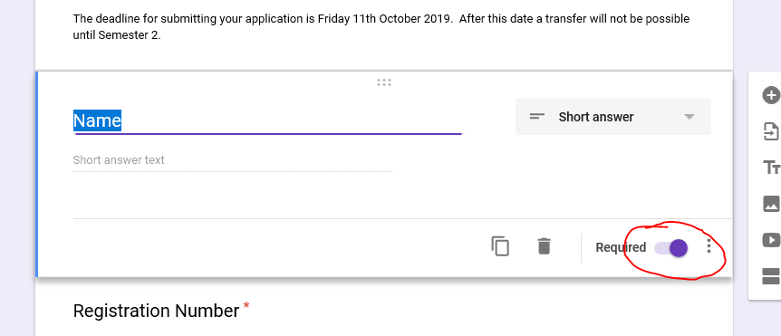

- Create the confirmation of submission message by going into settings (the cog icon) and selecting ‘presentation’:

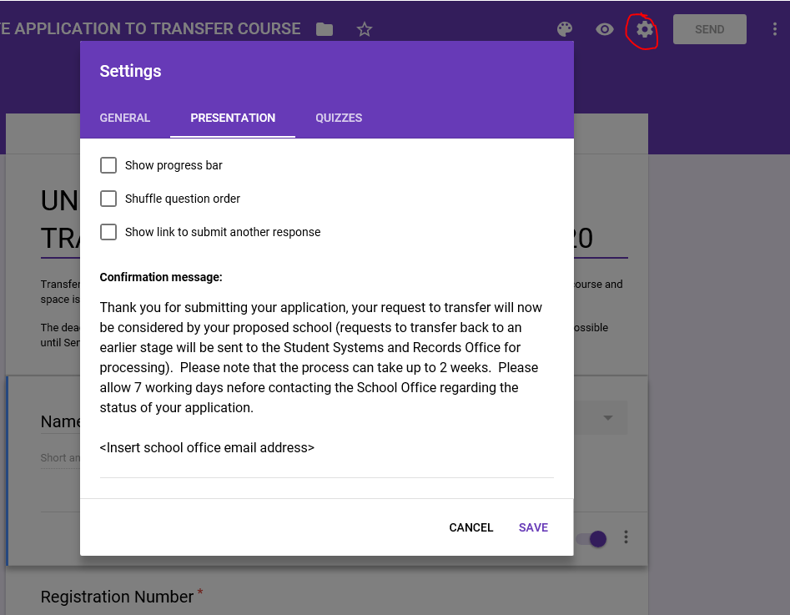

- Google Forms will autosave any changes you make. Once your form is ready to use, click on ‘Send’ and then the link icon to get the URL for the form:

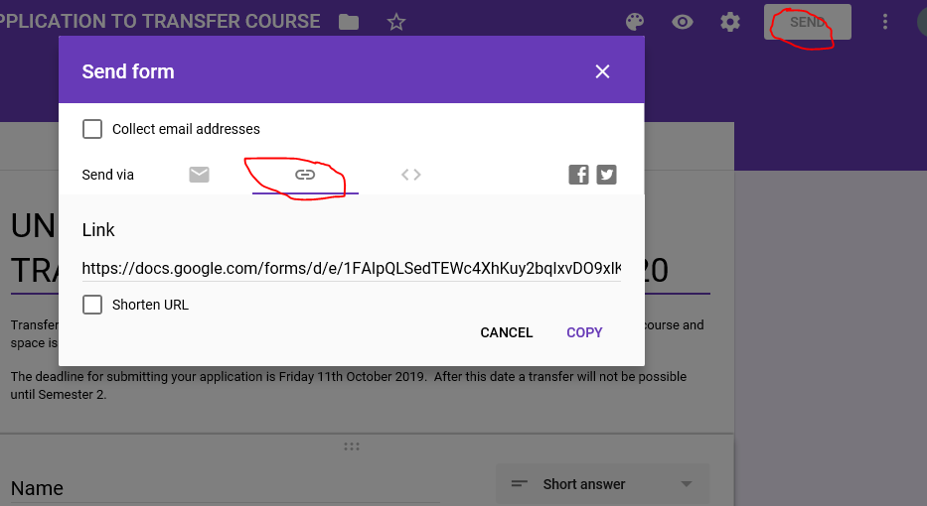

- This can then be copied and linked to your school’s webpage on transfers

- To open/close the form to responses, click on ‘Responses’ then use the toggle. You can also edit the message students see when the form is not accepting responses here:

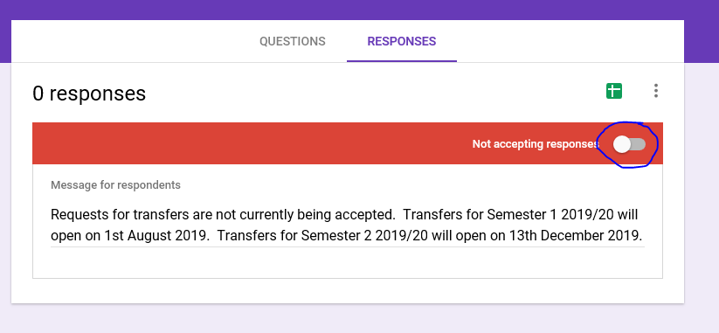

Appendix B: Templates for emails to student to confirm approval/rejection of transfer:

Approval of Application toTransfer Course

Dear xxxx,

I am pleased to inform you that your application to transfer into the 1st/2nd/3rd stage of the <insert name of course> has been approved. You are now expected to finish your course on 30th June <year>.

Your course title will now be updated and if your owning department has changed you will be allocated a new Academic Advisor.

Your new syllabus for the year/semester is as follows:

<Insert table of syllabus for stage/semester is transferring in semester 2>

As you have transferred to <name of course> you will need to select a module for Semester 1/Semester 2. You can find module outlines for the available option modules <attached/at web address>. Please reply with your preferred option choice(s) as soon as possible.

Once you have responded with your option choice, your syllabus will be updated and you will be allocated to teaching groups. Please note that it may take up to 24 hours for this to be reflected on your Sussex Direct timetable.

If you have any questions, please let me know.

Rejection of Application to Transfer Course

Dear xxxx,

I’m sorry to inform you that your request to transfer to 1st/2nd/3rd stage of the <insert name of course> has not been approved, as <give reason – please see below for examples>.

The Admissions Tutor has strongly recommended that you meet with you Academic Advisor (<name of AA>, copied in) to discuss your situation.

If you do not wish to continue on your current course, you may be able to temporarily withdraw from your studies for the rest of this academic year, and reapply to start <name of request course> from stage x in September. Your academic advisor should be able to offer you more guidance on this. You should also discuss this with the Admissions Tutor of <name of requested course>, <name of Admissions Tutor> (<their email address>), who will be able to advise on whether you may be accepted.

Please let us know if you have any further questions.

Example reasons for rejecting transfer:

‘you have not met the entry requirements for this course’
‘the structure of your current and/or proposed course would not allow you to gain the 120 credits required for each stage’
‘you have not taken core modules required to meet the course learning outcomes’
‘you do not have sufficient experience in the subject area’
‘the Admissions Tutor has concerns about your attendance and the results you have received so far’

