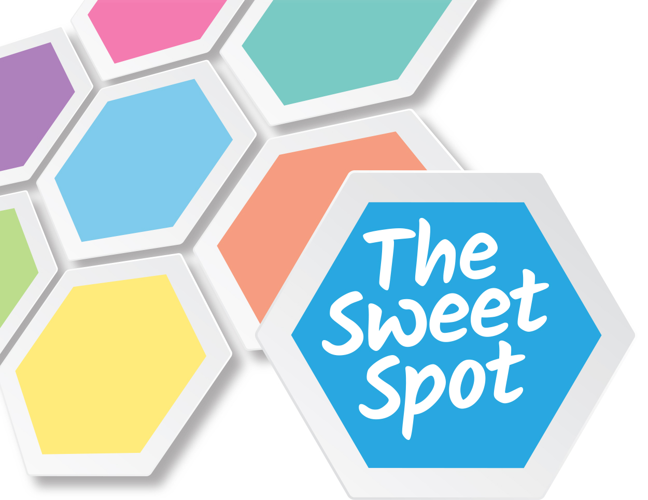
The Sweet Spot: Developing Alcohol Refusal Strategies

LESSON PLANS
YEAR 11
LESSON 2

TOPICS COVERED
Feel safe and secure
Enjoy the moment
Make a free choice
Strategy identification and intention

RESOURCES 7-8
Strategies to try
Practice journal

Lesson Two

Learning Objectives:
- To explore strategies I could use to manage social situations that involve alcohol.
- To think about using these strategies and how I can plan to try them myself.

Success Criteria:
- I have thought about my values and how they relate to my alcohol consumption.
- I have thought about how others can influence social situations that involve alcohol and the impact this may have on other’s thoughts, feelings and behaviours.
- I have applied my knowledge and understanding of the Sweet Spot to my own situation.
- I have related the Sweet Spot (video 2), to skills and strategies in my own life experience, thinking about how I may use them in the future.
- I can suggest strategies that would help me to feel safe and secure, to enjoy the moment, and to make a free choice.

Oral/Mental Starter (10 mins)
- Divide the class into two groups. Hold a classroom debate on one of the following topics, with one side acting as “pro” and the other as “con”:
- “Peer pressure to drink alcohol exists at this school”
- “It is hard/easy to be a non-drinker at this school”
- “There are plenty of activities to do in our community that don’t involve drinking”
The aim of the debate aims to get students to think and talk in a considered way about perceived social norms, perceived barriers to making healthy choices, and ways in which they can access alternative activities.

Main Activities (40 mins)
Video
- Show young people the Sweet Spot video 2, which addresses the final 3 themes of: feeling safe and secure, enjoying the moment and making a free choice.
Strategy identification
- Discuss the strategies shown in the video and positive and negative values of self-worth that they experienced during the previous lesson when they mapped out their own Sweet Spot (Re-refer to Resources 4 and 6 to support this).
- Can students suggest how a peer may empower or support those on the video to manage the situations more effectively before or during (rather than after) they drink or enter the situation? What strategies could they use? (Resource 3 may assist this). How could they help a friend to handle a situation? What could a friend do to help them? (Allocate 20 mins to this half of the main activity)
- Briefly re-cap lesson 1 and the values they hold and see as important to them which will enable them to plan strategies they can try today e.g. having self-control (slowing down rate of drinking while still feeling good), strong friendships (being safe and secure).
Flow chart/pathway map (20 minutes)
- Divide students into 6 groups, one group per theme. Talk through the Strategies To Try sheet (Resource 7), discussing when they may and may not be successful. Ask students to explore why and how strategies may work for them, including times when they have previously used these strategies in non-alcohol related situations, such as not missing curfew because of football practice, or having a pre-planned response to being asked to shop lift with peers (“My cousin couldn’t go on holiday because he got a conviction for shoplifting, I don’t fancy that for myself”).
- Have each group develop a flow chart/pathway map for their theme identifying significant decisions made using the strategies during which demonstrate how they or someone they know successfully arrived at reaching and maintaining the Sweet Spot – this may involving managing not to drink through choice, supporting and using the support of friends, or managing a risky situation.
- COLLECT FLOW CHARTS IN TO BE GIVEN TO RESEARCH PROJECT CO-ORDINATOR.
- If groups are open to role play, follow with a role play where they act out a scenario including positive strategies.

Plenary (10 mins)
Flow chart review
- Choose one group’s flow chart/pathway map that shows the theme and possible strategies clearly. Lead discussion about at the points in the flow charts/pathway maps they can identify HOW they used WHICH strategies. What are the significant decision points when strategies have been used? Highlight these on the chart/map.
- If these strategies weren’t used, what could the outcomes be e.g. being physically hurt, embarrassed, letting friends down, have consequences from parents/carers for not meeting curfew and add these to the chart/map as the pathway to excess.
Group reflection
- Reflect as a group on the positives of not drinking too much. Highlight to students that the outcomes of reaching the Sweet Spot or choosing not to drink are the same, as opposed to drinking in excess. What values, previously discussed, contributed to these outcomes? e.g. self-control, your personal boundaries.
- Reflect on success criteria – self-assess whether they have achieved none, some or all of them in this lesson.

Homework/Next Steps
Putting theory into practice
- Tell students to buddy up in pairs at the end of this lesson. Set homework to share with each other, as soon as is practical, ONE strategy that they are going to try next time they are in a social situation that will involve alcohol – they can share this face to face after class/school, via text, email, tweet, private blog – and state WHEN they will use it. Once each partner in the pair has tried using their strategy, they are to contact each other through the agreed medium and feedback if their strategy proved successful or not and the REASONS for this, i.e. WHY the strategy worked and what they would do next time (Resource 8).
- Encourage students to access the sweetspot.ac.uk website
- Encourage students to take the Strategies (Resource 7) sheets home so they have them to hand and can take their time to read them.
- ASK THEM TO RETURN PRACTICE JOURNAL (Resource 8) within one month (to allow time for practice).
- Advise students to keep practice journals anonymous, as quotes may be used on the web site to share with others why strategies did or did not work for students.

The Sweet Spot: Developing Alcohol Refusal Strategies
Resource Bundle 2

Resource 7

Strategies to Try

Here are some ideas of things you could try when you know you will be going into a social situation that involves alcohol. Some of them will appeal to you more than others. The important thing is that you are the expert on your own life, and that you try the ones that you think will work best for you. Think about your strengths and values and how these ideas fit best with YOU as your own person.

- Feel good before, during and after drinking
- Drink only what tastes good
- Feeing proud in your decisions makes the small things worth it
- Have a range of engaging friends and interests
- Plan ahead, especially when you first start exploring changes
- Take care of your friends
- Do what you can to keep a sense of safety about you
- If you don’t make it a big deal, most people won’t either
- Your friends will generally accept and support your decision
- Have quick, easy responses prepared for questions and drink offers
- Value your time, your priorities and the respect of the people you care about
- Think about the “done thing” or hidden rules and expectations amongst your friends about drinking
- Share your experiences and thoughts with a trusted friend
- Ask yourself: would I want to meet “drunk me”?
- Just get on with having a good time

On the web site there are more ideas (with more detai)l, that you can look at later. Below are examples of these. For the entire list, go to www.sweetspot.ac.uk

Stay hydrated to avoid a hangover

Spend time on hobbies and interests

Spend time with supportive people

Focus on why you’re there – dance!

Resource 8


My Practice Journal

Strategy I’m going to try e.g. holding a soft drink | What went well (e.g. didn’t get sick, my friends’ responses) | What could have been better (e.g. didn’t feel like the right strategy for me)
Strategy:

First time

Second time

Third time

Fourth time

